**AUTONOMOUS DRONE SURVEILLANCE SYSTEM**

**ABSTRACT**

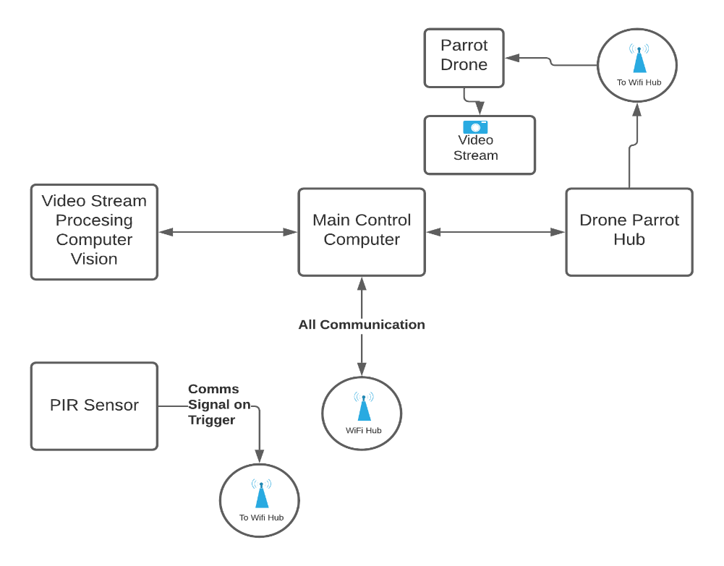This document describes an autonomous drone surveillance system with the ability to auto detect and focus on a target based on training data. In this document, the system described consists of drone from the parrot line up following their ability to be programmed and interacted with remotely over a distance using radio connection. Another benefit is the fact that they have some extra beneficial navigation sensors like GPS, compass, air pressure, gyroscope, etc.

The parrot drone is also chosen because after much research, it seemed to be the only available option to achieve the requirements with a relatively usable cost implication.

Arduino is also used as the microcomputer unit at the trigger part following its ease of setup and compatibility with most available sensor breakout boards and online support.

**PART DESCRIPTION**

1. PIR sensor controlled by an Arduino: This system is fitted with a wireless transmitter Wi-Fi to be precise. All comms between this module and the main control computer is made over this Wi-Fi.
2. Wi-Fi Hub: This is the central bus/node for inter-connectivity between all peripherals in the system. This will allow all the components to communicate in local area over Wi-Fi (Basically wireless access point).
3. Main Control Computer: Main control computer is basically a traditional windows or mac laptop which will be configured with the appropriate tools for interfacing with the parrot drone and also carrying out machine learning activity. The computer will also be connected to the wifi hub as it will be the server.
4. Parrot drones and Parrot drone hub: The parrot drone hub is the bundled package for interfacing with parrot drones programmatically. Parrot drones with cameras are the drones of choice for this project.
5. Computer Vision on video stream: The video stream is the feed live from the parrot drones and this feed is going to be manipulated and processed at the main control computer. The data from the stream processed will be used as feedback for controlling the drone and focusing on a target.

**METHODOLOGY**

As described in the abstract chapter of this document, this project is an autonomous drone surveillance system with machine learning capability for tracking, image classification, and object detection features.

**Step 1**: The project begins with the trigger. Once everything is powered up, the trigger unites and the server connects to the access points.

**Step 2**: The server is started on the local server and listens to incoming requests from both trigger and streams from drones.

**Step 3**: (Activate Trigger) Upon activation of the trigger, a signal is sent to the server containing the location and ID of the trigger activated.

**Step 4**: Drone is activated according to the closest to the trigger event and is sent to the location addressed.

**Step 5**: (Drone Seeking Target) The drone arrives the GPS coordinates and faces the direction of the target, then begins a live stream.

The live stream is analyzed and searched for a human being as trained, and then locked on. After a preset event i.e. the target is out of range, then the drone returns to the start point.

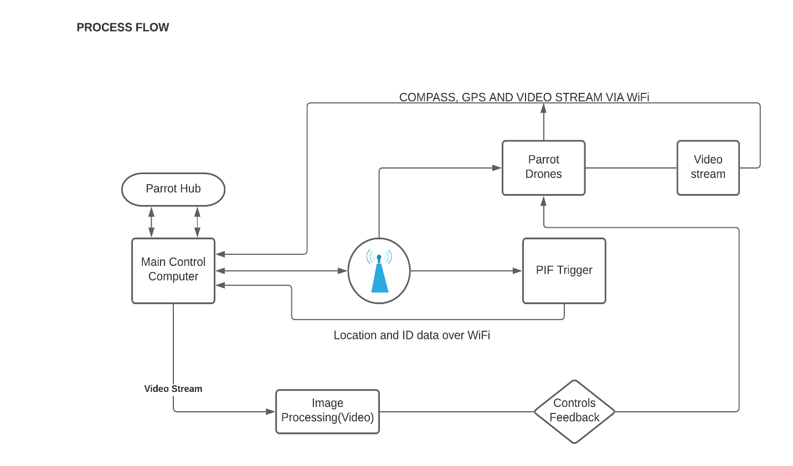**Step 6**: System continues monitoring for trigger event.